Module–1(Fundamental)

- What is SDLC
SDLC is a series of steps, or phases, that provide a model for development.

- What is software testing?
Software testing is a process used to identify the correctness, completeness and quality of developed computer software.

- What is agile methodology?
Agile means delivering working software in small parts with continuous feedback and improvement.
Key point:
- Interactive incremental model
- Work divided into small parts
- Daily meeting
- Continuous testing and feedback
- Continuous improvement
- Customer are involved in every phase
- Fast and flexible delivery

- What is SRS
A software requirement specification is a complete description of the behaviour of the system to be development.

- What is oops
Object-oriented programming (OOP) is a computer programming model that organizes software design around data

- Write Basic Concepts of oops
- Class
- Object
- Encapsulation
- Inheritance
- Polymorphism
- Abstraction

- What is object
Object gives permission to access functionality of class.

- What is class
It is a collection of a data and function.

- What is encapsulation
Encapsulation is Wrapping of data

- What is inheritance
To derive attribute of some other class

- What is polymorphism
Polymorphism means One name multiple form

- Draw Usecase on online bill payment system (Paytm)
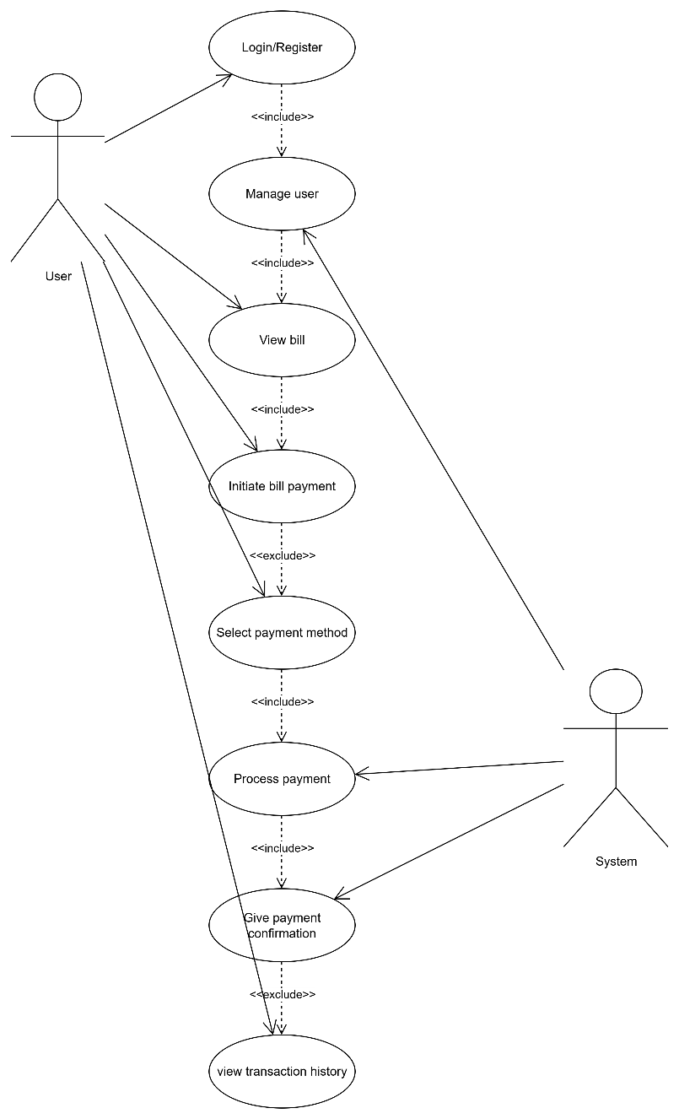

- Draw Usecase on banking system for customers.

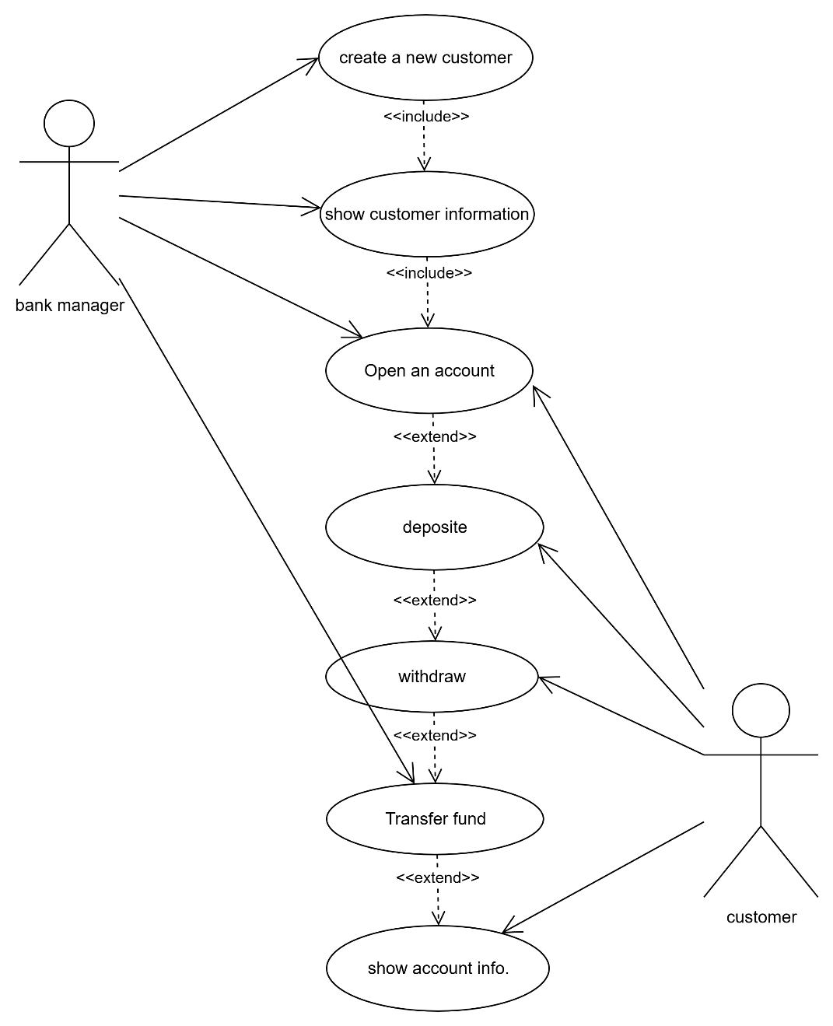

- Draw Usecase on Broadcasting System.
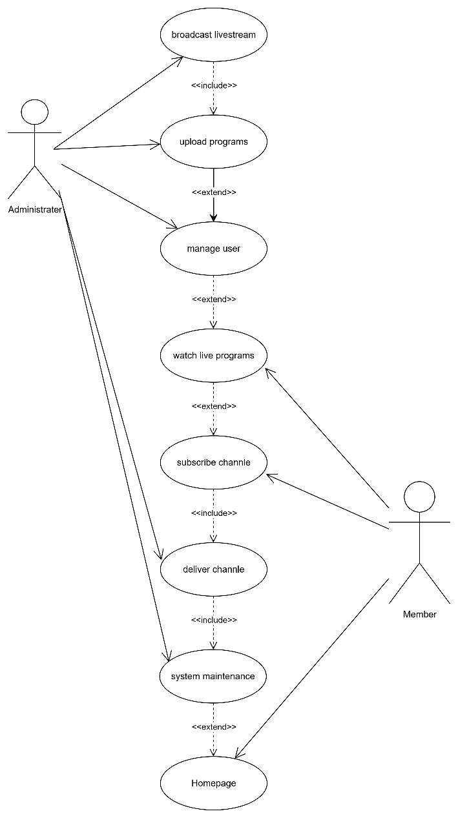

- Write SDLC phases with basic introduction
- Requirement Gathering: Collect details from client about the project like functional requirements and non-functional requirements.
- Analysis: To analyse the requirements and convert the CRS into SRS.
- Design: To prepare design as per requirement
- Implementation: coding
- Testing and Deployment: To verify the correctness completeness and quality of the software development and deploy it.

- Explain Phases of the waterfall model
- Requirement
- Analysis
- Design
- Implementation
- Testing
- maintenance
- Write phases of spiral model
- Planning
- Risk Analysis
- Engineering
- Customer evaluation

- Explain working methodology of agile model and also write pros and cons.
Agile means delivering working software in small parts with continuous feedback and improvement.
Key point:
- Interactive incremental model
- Work divided into small parts
- Daily meeting
- Continuous testing and feedback
- Continuous improvement
- Customer are involved in every phase
- Fast and flexible delivery
Pros:
1. Quick delivery
2. Easy to change requirements
3. Continuous collaboration with customers

- Draw usecase on OTT Platform.

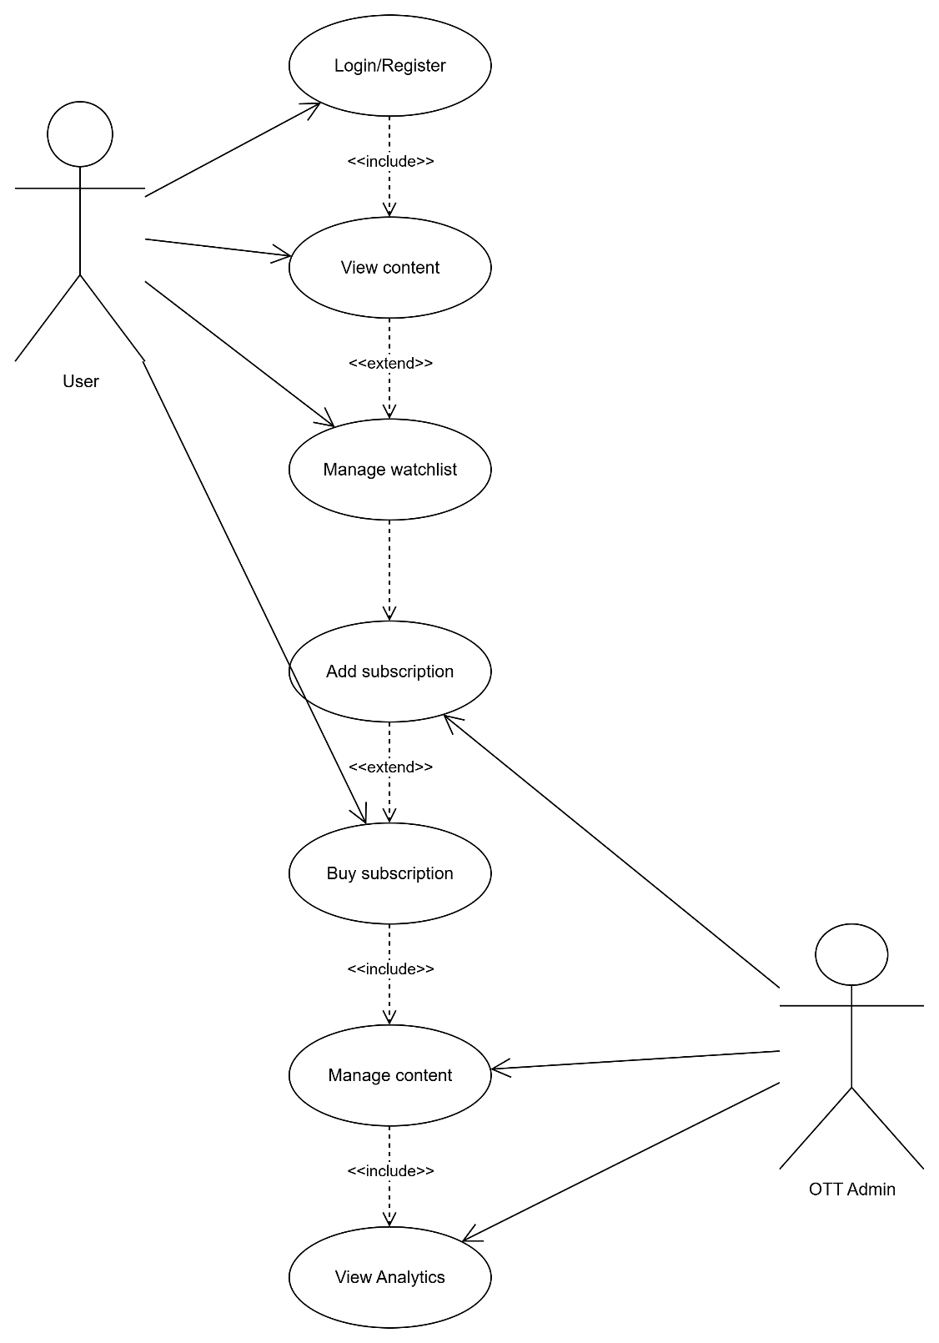

- Draw usecase on E-commerce application

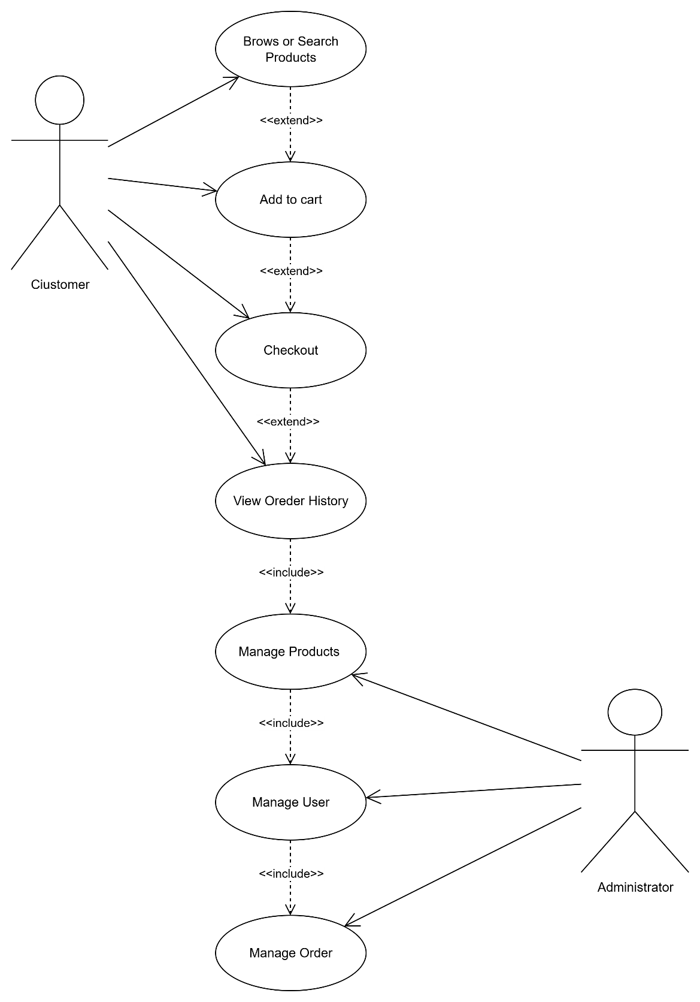

- Draw usecase on Online shopping product using payment gateway.

